A STUDY ON IMAGE PROCESSING TECHNIQUES USING TAMIL SCULPTURE IMAGERY

Course Name: Image Processing
Course Code: CS23045

By:
Rithik Rajkoomar – 2023103008 - CSE ‘P’
Mohammed Jasim J – 2023103013 - CSE ‘N’
Introduction:
Image processing is a fundamental area in computer science that involves the manipulation and analysis of digital images to enhance their quality and extract meaningful information. It plays a crucial role in various domains such as medical imaging, computer vision, pattern recognition, and digital forensics. With the advancement of computational techniques, image processing has evolved to include both spatial and frequency domain operations, enabling more efficient and accurate analysis of visual data.
In this study, a comprehensive set of image processing techniques has been applied to Tamil sculpture imagery, which contains intricate patterns, textures, and structural details. These images serve as an ideal dataset due to their rich visual content, varying illumination conditions, and complex geometrical features. The objective of this project is to analyse how different image processing methods affect the visual and statistical properties of such images.
The implemented techniques span across multiple domains of image processing, including basic operations such as sampling and quantization, enhancement methods like histogram equalization and filtering, frequency domain transformations using Fourier techniques, and advanced methods such as edge detection, thresholding, and clustering. Each technique has been applied to the input images to generate corresponding outputs, enabling a comparative study of their effects.
For every transformation, both visual and quantitative analyses have been performed. The changes in pixel intensity distribution, structural properties of the image matrix, frequency components, and feature characteristics have been examined using relevant statistical measures. Additionally, histograms and other metrics have been used to understand how information content, contrast, and texture are altered through different processing techniques.
The results of this study provide a clear understanding of how various image processing techniques influence image characteristics at both the pixel and structural levels. This analysis not only demonstrates the practical implementation of theoretical concepts but also highlights the significance of choosing appropriate techniques based on the nature of the input imagery and the desired outcome.

Input Images:
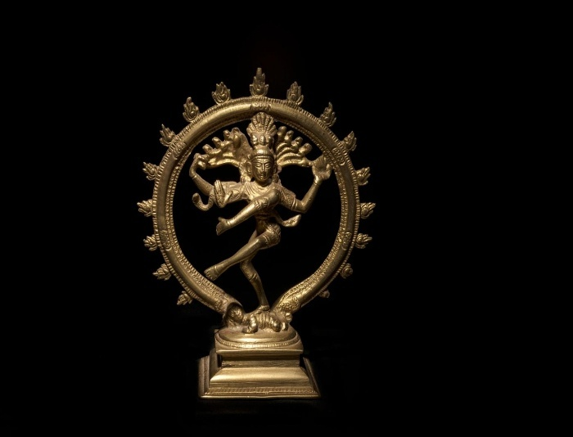
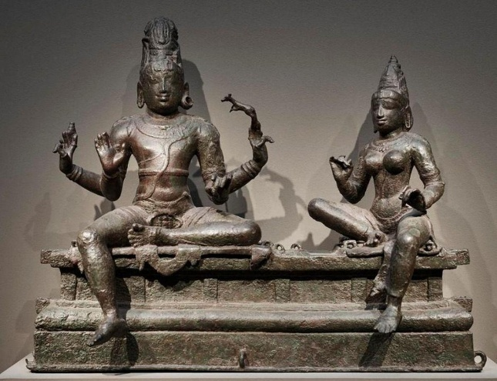
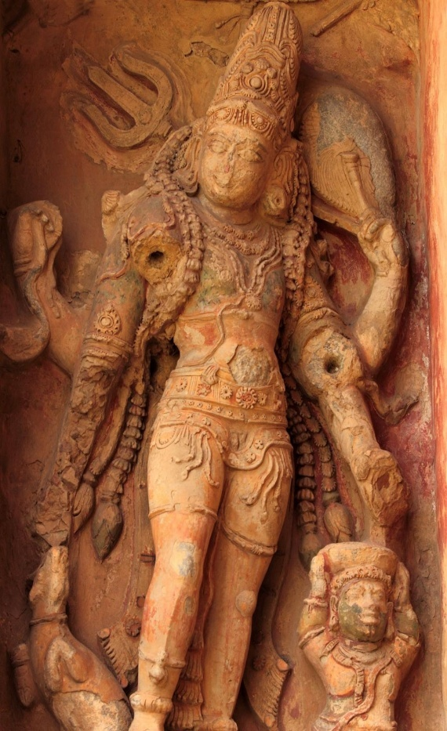
Image Processing Techniques:
- Fundamentals of Image Processing
  - Sampling
  - Quantisation
  - Pixel Connectivity
  - Distance Transform
  - Image Negative
- Image Enhancement Techniques
  - Histogram Equalisation
  - Thresholding
  - Gaussian Smoothening and Sharpening
  - FFT
- Image Restoration and Multi-Resolution Analysis
  - Noise + Restoration
  - Image Pyramid
  - Wavelet Transform
  - Order Statistic Filter (Median Filter)
  - Image Compression
- Image Segmentation and Feature Analysis
  - Edge Detection
  - Region-Based Segmentation
  - Texture Analysis
  - Feature Reduction (PCA)
- Image Classification and Security Techniques
  - KNN Classification
  - SVM Classification
  - K-means Clustering
  - Hierarchical Clustering
  - Steganography
  - Digital Watermarking
  - Digital Compositing

Image Processing Techniques – Analysis and Results:
In this section, various image processing techniques are applied to the selected Tamil sculpture images. Each technique is analysed based on its impact on pixel intensity, structural properties, and frequency components of the image. The results are presented using corresponding output images along with statistical and analytical interpretations to understand the effect of each transformation.
1. Sampling:
Input Image: Output Image:
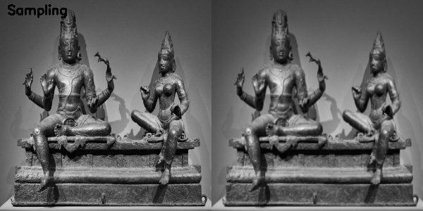
Input Image:
The input image is a grayscale Tamil sculpture image containing fine structural details, smooth intensity variations, and intricate textures. The image has an initial resolution of 392 × 512 pixels, representing a relatively high spatial resolution.

Technique Applied:
Sampling is the process of reducing the number of pixels used to represent an image by decreasing its spatial resolution. In this case, the image dimensions are reduced by a factor of 2 in both directions, resulting in a lower-resolution representation.
Observed Output:
The output image shows a visibly reduced level of detail compared to the input. Fine textures and sharp edges appear slightly blurred or less defined. While the overall structure of the sculpture remains recognizable, subtle features such as surface carvings and edges lose clarity due to the reduced pixel density.
Statistical Analysis:
Matrix-Level Changes:
- Resolution: (392 × 512) → (196 × 256)
- Total number of pixels is reduced by approximately 75%, significantly decreasing the amount of spatial information available in the image.
Pixel-Level Changes:
- Entropy: 7.40 → 7.34
Interpretation:
The reduction in resolution decreases the number of pixels representing the image, leading to loss of fine spatial details. This results in slight blurring and reduced sharpness in the output image. The small decrease in entropy (7.40 to 7.34) indicates a minor loss of information, while the overall intensity distribution remains largely preserved. Thus, sampling primarily affects spatial resolution with limited impact on global image characteristics.

2. Quantisation:
Input Image: Output Image:
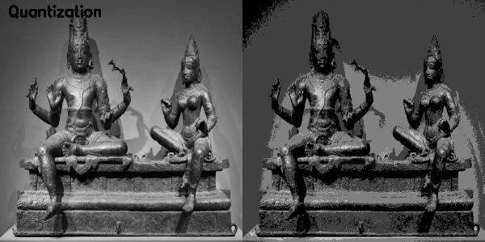
Input Image:
The input image is a grayscale Tamil sculpture image with a wide range of intensity values representing smooth gradients, fine textures, and detailed surface features. The image contains multiple gray levels, allowing for high visual fidelity and gradual transitions between intensities.
Technique Applied:
Quantization is the process of reducing the number of distinct intensity levels in an image. In this case, the pixel intensity values are grouped into a limited number of discrete levels, significantly reducing the grayscale resolution.
Observed Output:
The output image exhibits noticeable loss of smooth intensity transitions. Gradual variations in shading are replaced with distinct intensity bands, resulting in a banding effect. Fine texture details appear flattened, and regions with similar intensities are merged, reducing visual depth while still preserving the overall structure of the image.
Statistical Analysis:
Pixel-Level Changes:
- Unique intensity values: 251 → 4
- Significant reduction in grayscale levels, indicating heavy compression of intensity information.
Interpretation:
The drastic reduction in unique intensity values leads to grouping of pixel intensities into a few discrete levels, causing loss of detail and smooth gradients. This results in visible banding and reduced visual quality. Quantization primarily affects the intensity resolution of the image, making it suitable for compression but at the cost of information loss.

3. Pixel Connectivity:
Input Image: Output Image:
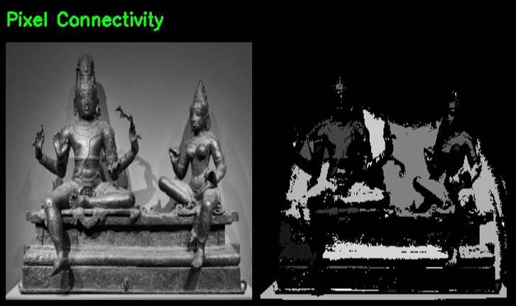
Input Image:
The input image is a grayscale Tamil sculpture image containing continuous intensity variations, detailed textures, and well-defined structural components. The image exhibits smooth transitions between foreground and background regions.
Technique Applied:
Pixel connectivity is used to identify and label connected regions in a binary image based on pixel adjacency (typically 4-connectivity or 8-connectivity). The grayscale image is first converted into a binary image through thresholding, after which connected components are detected and grouped.
Observed Output:
The output image appears as a binary representation where pixels are classified into foreground (white) and background (black). Distinct connected regions corresponding to parts of the sculpture are highlighted, while irrelevant or less significant regions are removed. The structure of the main objects is preserved, but fine intensity details and textures are lost due to binarization.
Analysis:
Pixel-Level Changes:
- Continuous grayscale intensity values are converted into two discrete levels (0 and 255).
- Loss of gradual intensity transitions results in removal of subtle details.
Structural (Connectivity) Changes:
- Pixels are grouped into connected components based on adjacency.
- Regions belonging to the sculpture are identified as continuous segments, while isolated noise or background regions are suppressed.
Interpretation:
Pixel connectivity simplifies the image by converting it into distinct connected regions, making it easier to identify object structures. While this enhances structural segmentation, it removes fine details and intensity variations, making it more suitable for tasks like object detection and region analysis rather than visual enhancement.

4. Distance Transform:
Input Image: Output Image:
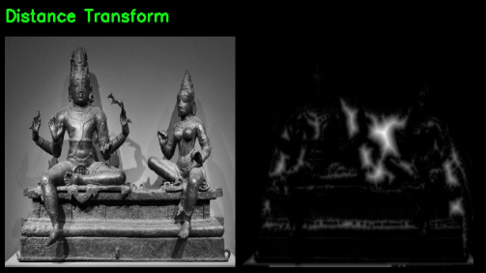
Input Image:
The input image is a grayscale Tamil sculpture image containing detailed structural elements and varying intensity regions. The image includes both foreground objects (sculptures) and background regions with gradual intensity transitions.
Technique Applied:
Distance Transform is applied to a binary version of the image, where each pixel is assigned a value corresponding to its distance from the nearest background (zero-valued) pixel. Typically, brighter values in the output represent pixels that are farther from the boundaries of objects.
Observed Output:
The output image highlights regions based on their distance from object boundaries. Areas closer to edges appear darker, while regions farther from boundaries (such as central parts of objects) appear brighter. The sculpture structure is not directly visible in detail; instead, the output emphasizes distance-based intensity variations, creating a blurred, glowing representation of object regions.
Analysis:
Pixel-Level Changes:
- Pixel intensities no longer represent original grayscale values but instead encode distance information.
- Bright regions correspond to pixels located farther from edges, while dark regions indicate proximity to boundaries.
Structural Changes:
- The original structural details are transformed into a distance-based representation.
- Object interiors are emphasized, while edges and boundaries are suppressed.
- The image loses texture and fine details, retaining only spatial relationships relative to boundaries.
Interpretation:
Distance Transform converts the image into a representation based on proximity to object boundaries, highlighting the internal structure of regions rather than surface details. This makes it useful for applications such as object segmentation, skeletonization, and shape analysis, where spatial relationships are more important than visual appearance.

5. Image Negative
Input Image: Output Image:
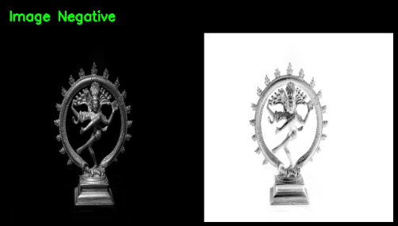
Input Image:
The input image is a grayscale Tamil sculpture image with a dark background and relatively low mean intensity. The sculpture appears prominently due to brighter intensity values against the darker surroundings.
Technique Applied:
Image negative transformation is a point processing technique where each pixel intensity value r is transformed to s=255−rs =255−r. This operation inverts the grayscale levels, converting dark regions to bright and vice versa.
Observed Output:
The output image shows a complete inversion of brightness levels. The originally dark background becomes bright, while the sculpture appears darker in comparison. Structural details remain intact, but the overall visual perception of the image is reversed, enhancing features that were previously less noticeable.
Statistical Analysis:
Pixel-Level Changes:
- Mean intensity: 12.42 → 242.58
- Standard deviation: 35.67 → 35.67 (remains unchanged)
- Minimum intensity: 0 → 1
- Maximum intensity: 254 → 255
- Entropy: 7.28 → 7.28 (unchanged)
Interpretation:
Image negative transformation reverses the intensity distribution without altering the overall contrast or information content of the image. The unchanged standard deviation and entropy indicate that the variation and information remain the same, while the significant shift in mean reflects inversion of brightness. This technique is useful for enhancing features in images where dark regions dominate or when inverse representation improves visibility.

6. Histogram Equalisation
Input Image: Output Image:
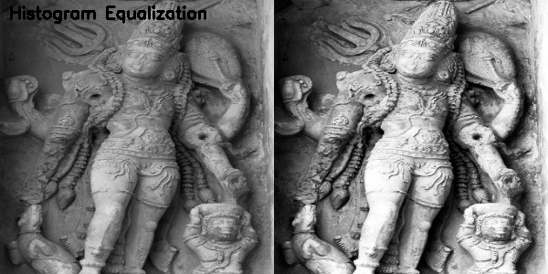
Input Image: Output Image:
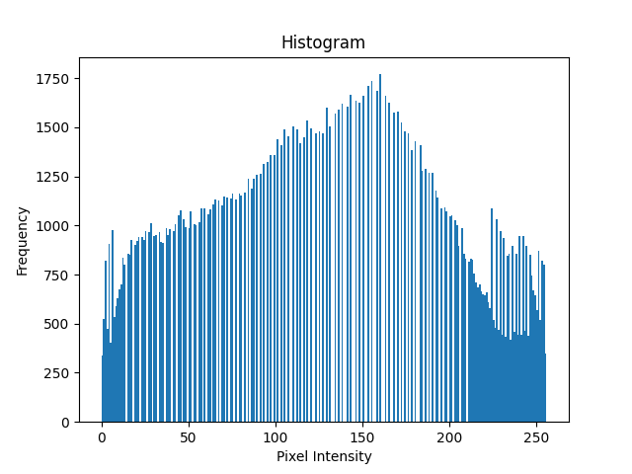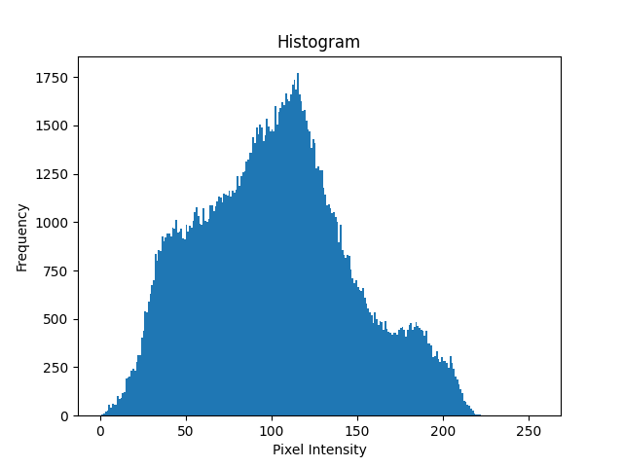
Input Image:
The input image is a grayscale Tamil sculpture image with uneven illumination and moderate contrast. The histogram of the input image is concentrated within a limited range of intensity values, indicating that many pixel intensities are clustered, leading to reduced contrast and less distinguishable details.
Technique Applied:
Histogram Equalization is a contrast enhancement technique that redistributes the pixel intensity values of an image such that the histogram becomes more uniformly spread across the entire intensity range (0–255). This improves the visibility of features by enhancing intensity differences.
Observed Output:
The output image exhibits significantly improved contrast. Fine details, textures, and structural features of the sculpture become more prominent and easier to distinguish. The histogram of the output image shows a more uniform distribution across intensity levels, indicating better utilization of the available grayscale range.
Statistical Analysis:
Histogram-Based Changes:
- Histogram variance: 1983.43 → 5415.41
- The spread of intensity values has increased significantly, indicating enhanced contrast.
Interpretation:
The increase in histogram variance indicates that the pixel intensities are more widely distributed across the grayscale range, resulting in improved contrast. This redistribution enhances the visibility of finer details and textures in the image. Histogram equalization is therefore effective in improving image quality, especially in images with poor contrast or uneven lighting conditions.

7. Gaussian Smoothening and Sharpening
Input Image: Output Image:
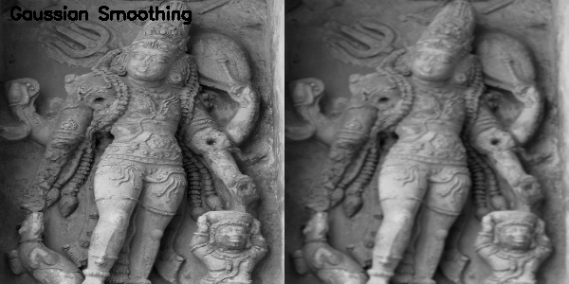
Input Image: Output Image:
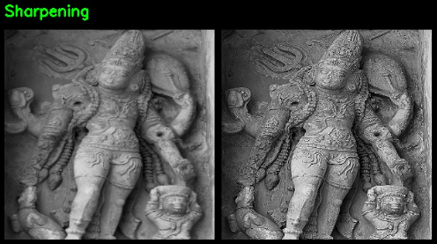

Gaussian Smoothing
Input Image:
The input image is a grayscale Tamil sculpture image containing fine textures, edges, and high-frequency details. These include surface carvings, edges, and slight intensity variations that contribute to the overall detail of the image.
Technique Applied:
Gaussian Smoothing is a spatial filtering technique that reduces noise and detail by applying a Gaussian kernel. It works by averaging neighboring pixel values, thereby suppressing high-frequency components in the image.
Observed Output:
The output image appears smoother and slightly blurred compared to the input. Fine details and sharp edges are softened, and textures become less pronounced. The overall structure of the sculpture is preserved, but intricate details are reduced.
Statistical Analysis:
Frequency-Based Changes:
- Frequency energy: 1011064729.46 → 463878815.86
- Significant reduction in high-frequency components.
Interpretation:
The decrease in frequency energy indicates that high-frequency components, such as noise and fine details, have been effectively removed. This results in a smoother image with reduced sharpness. Gaussian smoothing is therefore useful for noise reduction and pre-processing before further analysis.

Sharpening
Input Image:
The input image is the same grayscale Tamil sculpture image with moderate contrast and visible fine details, including edges and textures.
Technique Applied:
Sharpening is an enhancement technique that emphasizes edges and fine details by amplifying high-frequency components in the image. This is typically achieved using convolution filters that enhance intensity differences between neighbouring pixels.
Observed Output:
The output image shows enhanced edges and increased clarity of textures. Fine details such as carvings and boundaries become more prominent. The image appears more defined, though slight amplification of noise may also be observed.
Statistical Analysis:
Pixel-Level Changes:
- Mean intensity: 102.13 → 102.94 (slight increase)
- Standard deviation: 44.54 → 61.17 (significant increase in contrast)
- Entropy: 7.46 → 7.71 (increase in information content)
Interpretation:
The increase in standard deviation and entropy indicates enhanced contrast and greater detail visibility. Sharpening amplifies high-frequency components, making edges and textures more prominent. This improves visual clarity but may also increase noise, making it suitable for enhancing important features in the image.

8. Fast Fourier Transform (FFT):
Input Image: Output Image:
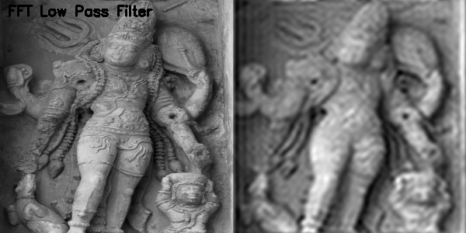
Input Image:
The input image is a grayscale Tamil sculpture image containing a combination of low-frequency components (overall structure and smooth regions) and high-frequency components (edges, fine textures, and detailed carvings). These high-frequency components contribute to the sharpness and clarity of the image.
Technique Applied:
The FFT (Fast Fourier Transform) Low Pass Filter is applied in the frequency domain to suppress high-frequency components while preserving low-frequency components. This is achieved by transforming the image into the frequency domain, applying a mask that retains low frequencies, and then converting it back to the spatial domain.
Observed Output:
The output image appears significantly blurred compared to the input. Fine details, edges, and textures are greatly reduced, while the overall structure and general shape of the sculpture are preserved. The image exhibits a smooth appearance with diminished sharpness.
Statistical Analysis:
Frequency-Based Changes:
- Frequency energy: 1011064729.46 → 281452098.50
- Substantial reduction in high-frequency components.
Interpretation:
The large decrease in frequency energy indicates effective removal of high-frequency components, which are responsible for edges and fine details. As a result, the image becomes smoother and blurred, retaining only the coarse structural information. This demonstrates that low pass filtering is effective for noise reduction and smoothing but leads to loss of detail and sharpness.

9. Noise + Restoration
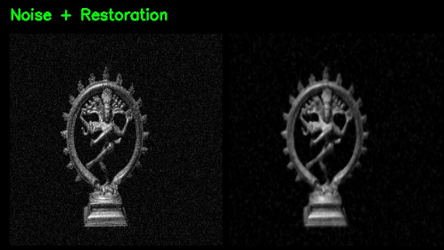
Input Image:
The input image is a grayscale Tamil sculpture image that has been corrupted with noise. The noise appears as random intensity variations across the image, degrading the visual quality and obscuring fine details and structural features.
Technique Applied:
Noise is artificially introduced into the image to simulate degradation, typically in the form of Gaussian noise. A restoration technique (such as median filtering) is then applied to reduce the noise while attempting to preserve important image features like edges and structures.
Observed Output:
The noisy input image shows significant random variations in pixel intensities, making the image appear grainy and reducing clarity. After restoration, the output image appears smoother with reduced noise. While most of the noise is removed, some blurring of fine details and edges is observed due to the filtering process.
Statistical Analysis:
Pixel-Level Changes:
- Mean intensity: 20.81 → 13.70
- Standard deviation: 36.59 → 31.53 (reduction in variation)
- Entropy: 4.66 → 3.96 (decrease in randomness)
- Maximum intensity: 255 → 227
Interpretation:
The decrease in standard deviation and entropy indicates effective noise reduction, as random intensity variations are suppressed. However, the smoothing effect of restoration also leads to slight loss of fine details and edges. This demonstrates the trade-off between noise removal and detail preservation in image restoration techniques.

10. Image Pyramid:
Input Image: Output Image:
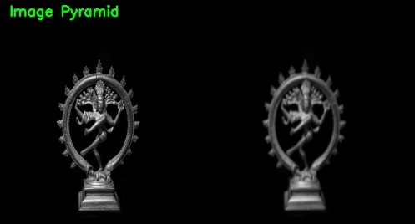
Input Image:
The input image is a grayscale Tamil sculpture image with high spatial resolution, containing fine details, edges, and intricate textures. The image exhibits clear structural features and intensity variations.
Technique Applied:
Image pyramids involve representing an image at multiple resolutions. In this case, a Gaussian pyramid is used where the image is progressively down-sampled (reduced in resolution) and then up-sampled back, resulting in a lower-detail version of the original image.
Observed Output:
The output image appears blurred and less detailed compared to the input. Fine textures and sharp edges are reduced, while the overall structure of the sculpture remains preserved. The image looks smoother due to the loss of high-frequency details during the down-sampling and up-sampling process.
Statistical Analysis:
Pixel-Level Changes:
- Mean intensity: 12.42 → 12.39 (almost unchanged)
- Standard deviation: 35.67 → 32.58 (slight reduction in contrast)
- Entropy: 7.28 → 7.41 (slight variation in information content)
- Maximum intensity: 254 → 225
Interpretation:
The minimal change in mean intensity indicates that the overall brightness is preserved, while the decrease in standard deviation reflects reduced contrast due to smoothing. The loss of high-frequency details during pyramid processing leads to a smoother image with reduced sharpness. Image pyramids are useful for multi-resolution analysis but result in some loss of fine details.

11. Wavelet Transform:
Input Image: Output Image:
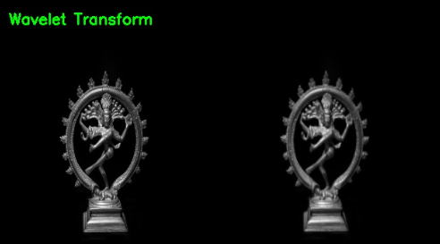
Input Image:
The input image is a grayscale Tamil sculpture image containing detailed textures, sharp edges, and varying intensity regions. It includes both high-frequency components (edges and fine details) and low-frequency components (overall structure and smooth regions).
Technique Applied:
Wavelet Transform is a multi-resolution analysis technique that decomposes an image into different frequency sub-bands. It separates the image into approximation (low-frequency) and detail (high-frequency) components, allowing analysis at multiple scales.
Observed Output:
The output image represents the approximation component of the wavelet transform, where the overall structure of the sculpture is preserved while fine details and high-frequency components are reduced. The image appears smoother with slightly diminished sharpness, as high-frequency information such as edges and textures is partially removed.
Analysis:
Frequency-Based Changes:
- High-frequency components (edges and textures) are suppressed.
- Low-frequency components (overall structure and shape) are retained.
Structural Changes:
- The image retains its general form but loses fine surface details.
- Texture information is reduced, resulting in a smoother appearance.
Interpretation:
Wavelet transform enables multi-resolution representation by separating image components based on frequency. The approximation image highlights the overall structure while reducing fine details. This makes it useful for applications such as compression, denoising, and feature extraction, where both spatial and frequency information are important.

12. Order Statistic Filter (Median Filter):
Input Image: Output Image:
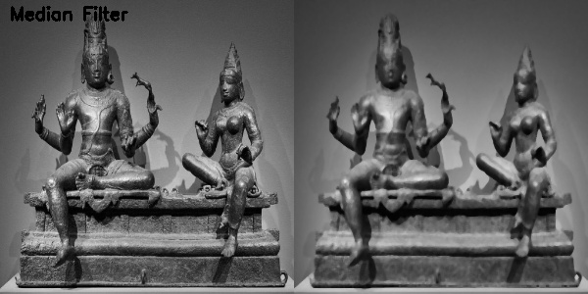
Input Image:
The input image is a grayscale Tamil sculpture image containing fine textures, sharp edges, and slight intensity variations. These details include intricate carvings and surface patterns that contribute to the overall clarity of the image.
Technique Applied:
The Median Filter is an order statistic filter used primarily for noise reduction. It replaces each pixel value with the median of its neighboring pixel values, effectively removing noise while preserving edges better than linear smoothing filters.
Observed Output:
The output image appears smoother with reduced noise and less granular variation compared to the input. However, there is a slight blurring of fine details and edges, especially in regions with intricate textures. The sculpture remains clearly recognizable, but small surface patterns and sharp transitions are softened due to the filtering process.
Statistical Analysis:
Pixel-Level Changes:
- Entropy: 7.40 → 7.30
- Slight reduction in randomness and intensity variation.
Interpretation:
The decrease in entropy indicates that noise and minor intensity variations have been reduced. The median filter effectively smooths the image while preserving major structural features, though some fine details are lost. This makes it suitable for noise removal while maintaining edge information better than standard smoothing techniques.

13. Image Compression:
Input Image: Output Image:
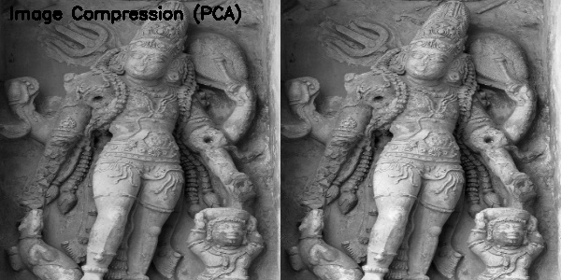
Input Image:
The input image is a grayscale Tamil sculpture image containing detailed textures, smooth intensity variations, and complex structural patterns. The image includes redundant information due to correlation between neighboring pixel intensities.
Technique Applied:
Image compression using Principal Component Analysis (PCA) reduces data redundancy by transforming the image into a set of principal components and retaining only the most significant components. This results in a compressed representation while preserving essential information.
Observed Output:
The output image appears visually very similar to the input, with the overall structure, edges, and textures largely preserved. However, there is a slight smoothing effect, where very fine details and minor variations are subtly reduced. The image maintains its perceptual quality despite compression.
Statistical Analysis:
Pixel-Level Changes:
- Entropy: 7.46 → 7.46 (no significant change)
Interpretation:
The unchanged entropy indicates that the overall information content of the image is effectively preserved despite compression. PCA removes redundancy rather than essential information, resulting in minimal perceptual loss. This demonstrates that PCA-based compression can achieve data reduction while maintaining image quality, making it suitable for efficient storage and transmission.

14. Edge Detection:
Input Image: Output Image:
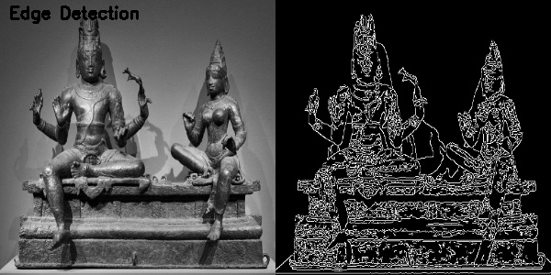
Input Image:
The input image is a grayscale Tamil sculpture image containing detailed structures, smooth intensity variations, and clearly defined object boundaries. Edges in the image correspond to significant intensity changes, representing boundaries of the sculpture and its features.
Technique Applied:
Edge Detection is a segmentation technique used to identify points in an image where intensity changes sharply. In this case, an edge detection algorithm (such as Canny) is applied to extract the boundaries and structural outlines of objects in the image.
Observed Output:
The output image highlights only the edges of the sculpture, with most non-edge regions appearing dark. Structural boundaries, contours, and prominent features are clearly visible, while textures and uniform regions are suppressed. The result is a sparse representation of the image focusing on important structural information.
Statistical Analysis:
Edge-Based Changes:
- Edge density: 0.1304 → 0.1384
- Slight increase in the proportion of detected edge pixels.
Interpretation:
The increase in edge density indicates that more edge pixels are detected in the processed image, emphasizing structural boundaries and contours. Edge detection effectively isolates important features while removing unnecessary intensity information, making it suitable for segmentation, object recognition, and feature extraction tasks.

15. Thresholding
Input Image: Output Image:
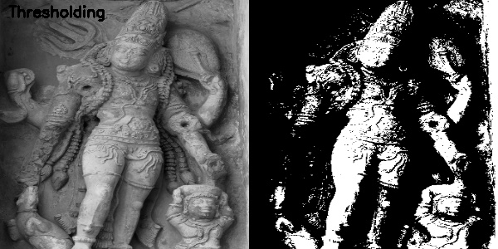
Input Image:
The input image is a grayscale Tamil sculpture image containing a wide range of intensity values with smooth transitions between foreground (sculpture) and background regions. The image includes detailed textures and varying illumination.
Technique Applied:
Thresholding is a segmentation technique that converts a grayscale image into a binary image by assigning pixel values based on a chosen threshold. Pixels with intensity values above the threshold are set to one level (typically 255), while those below are set to another level (typically 0).
Observed Output:
The output image is a binary representation consisting only of black and white regions. The main structure of the sculpture is clearly separated from the background, while fine details and gradual intensity variations are lost. Some regions may appear merged or simplified due to the strict binary classification.
Statistical Analysis:
Pixel-Level Changes:
- Unique intensity values: 2
- All grayscale variations are reduced to two discrete levels (0 and 255).
Interpretation:
Thresholding simplifies the image by reducing it to two intensity levels, effectively segmenting the main object from the background. While this enhances structural separation, it removes fine details and smooth intensity transitions. This makes thresholding suitable for segmentation and object detection tasks rather than detailed visual analysis.

16. Region-Based Segmentation:
Input Image: Output Image:
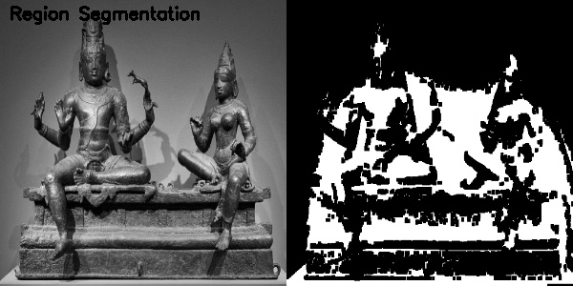
Input Image:
The input image is a grayscale Tamil sculpture image containing continuous intensity variations, detailed textures, and smooth transitions between foreground (sculpture) and background regions.
Technique Applied:
Region-Based Segmentation partitions an image into distinct regions based on similarity in pixel intensity. In this case, thresholding combined with morphological operations is used to group neighbouring pixels into coherent regions representing objects and background.
Observed Output:
The output image appears as a segmented binary representation where large regions corresponding to the sculpture are highlighted, while the background is separated. Fine details and gradual intensity variations are lost, resulting in a simplified image with clear region boundaries. Some small regions may appear merged or fragmented due to the segmentation process.
Statistical Analysis:
Pixel-Level Changes:
- Entropy: 7.40 → 0.89
- Significant reduction in intensity variability.
Interpretation:
The sharp decrease in entropy indicates that the image has been reduced to a few homogeneous regions with minimal intensity variation. Region-based segmentation effectively separates the main object from the background, making it useful for object detection and analysis, but it removes fine details and smooth transitions in the image.

17. Texture Analysis:
Input Image: Output Image:
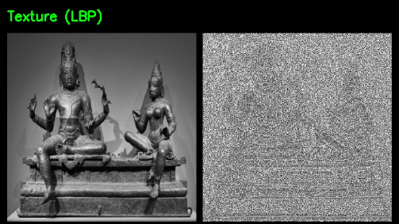
Input Image:
The input image is a grayscale Tamil sculpture image containing rich textures, intricate surface patterns, and varying intensity regions. These textures represent fine details such as carvings, edges, and material variations on the sculpture.
Technique Applied:
Local Binary Pattern (LBP) is a texture descriptor that encodes the local neighbourhood of each pixel by comparing it with surrounding pixels. Each pixel is assigned a binary code based on whether neighbouring pixel values are greater or lesser than the center pixel, effectively capturing local texture patterns.
Observed Output:
The output image appears as a highly textured representation with granular patterns. The original visual structure of the sculpture is no longer clearly visible, as the image now emphasizes local texture variations rather than intensity or shape. Regions with similar textures appear with similar patterns, while edges and fine details are encoded as distinct local variations.
Statistical Analysis:
Pixel-Level Changes:
- Mean intensity: 97.10 → 146.72
- Standard deviation: 42.95 → 86.39 (significant increase in variation)
- Entropy: 7.40 → 3.73 (reduction in intensity-based information)
Interpretation:
The increase in standard deviation indicates higher variation due to encoding of local texture patterns, while the decrease in entropy reflects loss of original intensity information. LBP transforms the image from an intensity-based representation to a texture-based representation, making it highly effective for texture classification and pattern recognition, but not for visual interpretation of the original scene.

18. Feature Reduction (PCA – Principal Component Analysis)
Input Image: Output Image:
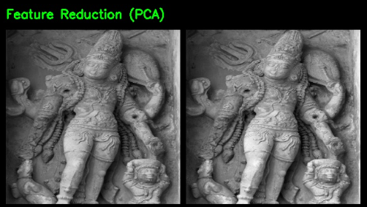
Input Image:
The input image is a grayscale Tamil sculpture image containing rich intensity variations, fine textures, and detailed structural features. The image includes redundant information across pixels due to high correlation between neighbouring intensity values.
Technique Applied:
Principal Component Analysis (PCA) is a dimensionality reduction technique that transforms the image data into a set of orthogonal components, retaining only the most significant components that capture the maximum variance. This reduces redundancy while preserving the most important information in the image.

Observed Output:
The output image appears visually similar to the input but with slight smoothing and loss of fine details. The overall structure and major features of the sculpture are preserved, while subtle textures and minor variations are reduced due to dimensionality compression.
Statistical Analysis:
Pixel-Level Changes:
- Mean intensity: 102.13 → 114.08
- Standard deviation: 44.54 → 50.47 (increase in contrast representation)
- Entropy: 7.46 → 7.46 (approximately unchanged)
- Maximum intensity: 226 → 254
Interpretation:
The preservation of entropy indicates that most of the essential information is retained despite dimensionality reduction. The slight increase in standard deviation suggests enhanced contrast in dominant features, while minor details are suppressed. PCA effectively reduces redundancy in the image while maintaining its key structural characteristics, making it useful for compression and feature extraction tasks.

19. KNN Classification:
Input Image: Output Image:
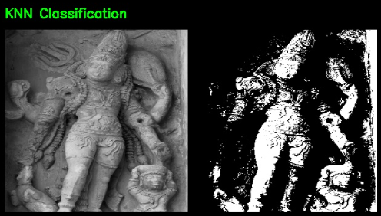
K-Nearest Neighbour (KNN) Classification
Input Image:
The input image is a grayscale Tamil sculpture image with continuous intensity variations representing different regions, textures, and structural elements. The pixel values vary smoothly across the image, capturing both foreground and background details.
Technique Applied:
K-Nearest Neighbour (KNN) Classification is a supervised learning algorithm used to classify pixel values based on their similarity to predefined classes. In this case, pixel intensities are classified into discrete categories (e.g., foreground and background) based on nearest intensity values.
Observed Output:
The output image appears as a segmented, high-contrast representation where pixels are classified into distinct regions. The image is largely binary or near-binary, with clear separation between different intensity classes. Structural components of the sculpture are preserved, but fine details and smooth intensity transitions are lost.
Statistical Analysis:
Pixel-Level Changes:
- Mean intensity: 102.13 → 68.71
- Standard deviation: 44.54 → 113.14 (significant increase in contrast)
- Entropy: 7.46 → 0.84 (drastic reduction in intensity variation)
- Maximum intensity: 226 → 255
Interpretation:
The significant increase in standard deviation indicates strong contrast between classified regions, while the sharp drop in entropy reflects reduced intensity variability due to discrete class assignment. KNN classification converts the image into distinct categories, effectively segmenting regions but eliminating gradual intensity transitions. This makes it useful for classification and segmentation tasks, though it reduces visual detail.

20. SVM Classification:
Input Image: Output Image:
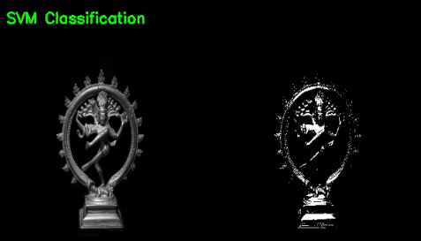
Input Image:
The input image is a grayscale Tamil sculpture image with continuous intensity variations representing both foreground (sculpture) and background regions. The image contains smooth gradients and detailed textures.
Technique Applied:
Support Vector Machine (SVM) is a supervised learning algorithm used for classification by finding an optimal decision boundary (hyperplane) that separates data into distinct classes. In this context, pixel intensities are classified into discrete categories (such as foreground and background) based on learned decision boundaries.

Observed Output:
The output image appears as a highly segmented representation, where only specific regions of the sculpture are retained while most of the background is suppressed. The result is sparse, with strong contrast between selected foreground pixels and the background. Fine details are partially preserved in key regions, but many intermediate intensity variations are removed.
Statistical Analysis:
Pixel-Level Changes:
Mean intensity: 12.42 → 7.33
Standard deviation: 35.67 → 42.60 (increase in contrast)
Entropy: 7.28 → 0.19 (significant reduction in intensity variation)
Maximum intensity: 254 → 255
Interpretation:
The sharp decrease in entropy indicates that the image has been reduced to a few distinct classes, resulting in minimal intensity variation. The increase in standard deviation reflects strong contrast between these classes. SVM classification effectively isolates important regions of the image, making it suitable for segmentation and object detection, but it significantly reduces visual detail and smooth intensity transitions.

21. K-means Clustering:
Input Image: Output Image:
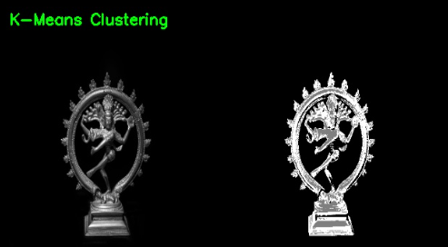
Input Image:
The input image is a grayscale Tamil sculpture image containing continuous intensity variations, detailed textures, and gradual transitions between foreground and background regions.
Technique Applied:
K-Means Clustering is an unsupervised learning algorithm that partitions image pixels into a predefined number of clusters based on similarity in intensity values. Each pixel is assigned to the nearest cluster center, effectively grouping similar intensity regions together.
Observed Output:
The output image appears segmented into distinct regions with reduced intensity variations. Pixels are grouped into clusters, resulting in a simplified representation where regions of similar intensity are merged. The sculpture structure is preserved, but fine details and gradual transitions are reduced, giving the image a more discrete and high-contrast appearance.
Statistical Analysis:
Pixel-Level Changes:
- Mean intensity: 12.42 → 25.70
- Standard deviation: 35.67 → 72.54 (significant increase in contrast between clusters)
- Entropy: 7.28 → 0.84 (reduction in intensity variability)
- Maximum intensity: 254 → 254
Interpretation:
The increase in standard deviation indicates stronger separation between clustered regions, while the reduction in entropy reflects decreased variability due to grouping of intensities. K-Means clustering simplifies the image by reducing the number of distinct intensity groups, making it effective for segmentation and pattern recognition, but at the cost of losing fine details and smooth transitions.

22. Hierarchical Clustering:
Input Image: Output Image:
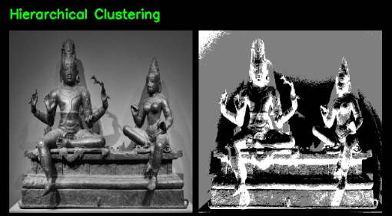
Input Image:
The input image is a grayscale Tamil sculpture image containing continuous intensity variations, fine textures, and smooth transitions between different regions. The image includes both foreground structures and background with gradual intensity changes.
Technique Applied:
Hierarchical Clustering is an unsupervised learning method that groups pixels based on similarity in intensity values using a hierarchical structure. Pixels are progressively merged into clusters based on distance measures, forming a tree-like structure of relationships between pixel groups.
Observed Output:
The output image appears segmented into distinct regions with strong intensity grouping. Large areas of similar intensities are merged, resulting in a simplified representation with reduced detail. The sculpture structure is still recognizable, but fine textures and gradual transitions are significantly reduced, leading to a more abstract and high-contrast appearance.
Statistical Analysis:
Pixel-Level Changes:
- Mean intensity: 97.10 → 110.58
- Standard deviation: 42.95 → 85.90 (significant increase in contrast)
- Entropy: 7.40 → 1.45 (substantial reduction in intensity variation)
- Maximum intensity: 250 → 254
Interpretation:
The increase in standard deviation indicates enhanced contrast between clustered regions, while the sharp decrease in entropy reflects reduced variability due to grouping of pixel intensities. Hierarchical clustering effectively segments the image into distinct regions, making it useful for pattern recognition and segmentation, but it reduces fine details and smooth intensity transitions.

23. Steganography:
Input Image: Output Image:
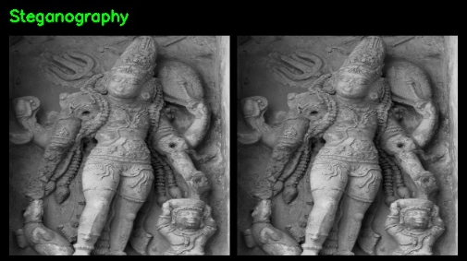
Input Image:
The input image is a grayscale Tamil sculpture image containing detailed textures, smooth intensity variations, and clearly defined structural features. The image serves as a cover medium for embedding hidden information.
Technique Applied:
Steganography is a data hiding technique in which secret information is embedded within an image without significantly altering its visual appearance. In this case, data is embedded by modifying the least significant bits (LSB) of pixel intensity values, ensuring minimal perceptual change.
Observed Output:
The output image appears visually identical to the input image, with no noticeable differences in structure, texture, or brightness. The embedded information is not visible to the human eye, preserving the original appearance of the image while securely storing hidden data.
Statistical Analysis:
Pixel-Level Changes:
- Mean intensity: 102.13 → 102.12 (negligible change)
- Standard deviation: 44.54 → 44.54 (unchanged)
- Entropy: 7.46 → 7.46 (unchanged)
- Maximum intensity: 226 → 226
Interpretation:
The negligible changes in statistical measures indicate that the embedding process does not significantly alter the image properties. Steganography preserves both visual quality and statistical characteristics, making the hidden information difficult to detect. This demonstrates its effectiveness for secure data hiding without compromising image integrity.

24. Digital Watermarking:
Input Image: Output Image:
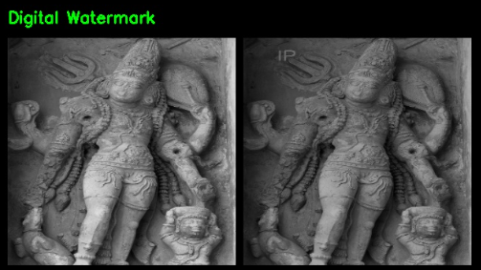
Input Image:
The input image is a grayscale Tamil sculpture image containing detailed textures, smooth intensity variations, and clearly defined structural features. The image serves as the base medium for embedding a visible watermark.
Technique Applied:
Digital Watermarking is a technique used to embed identifiable information into an image for purposes such as copyright protection and authentication. In this case, a watermark (text “IP”) is embedded into the image by blending it with the original using weighted addition, ensuring visibility while maintaining overall image quality.
Observed Output:
The output image shows the presence of a visible watermark embedded within the image, typically in a specific region. While the watermark is noticeable, the overall structure and details of the sculpture remain intact. There is a slight reduction in brightness and contrast due to blending of the watermark with the original image.
Statistical Analysis:
Pixel-Level Changes:
- Mean intensity: 102.13 → 81.77 (decrease in overall brightness)
- Standard deviation: 44.54 → 35.67 (reduction in contrast)
- Entropy: 7.46 → 7.06 (slight reduction in information variation)
- Maximum intensity: 226 → 181
Interpretation:
The decrease in mean intensity and standard deviation indicates that the watermarking process slightly reduces brightness and contrast due to blending. The small reduction in entropy suggests minimal loss of information. Digital watermarking successfully embeds identifiable information while preserving the overall visual structure, making it suitable for authentication and copyright protection with minimal impact on image quality.

25. Digital Compositing:
Input Image: Output Image:
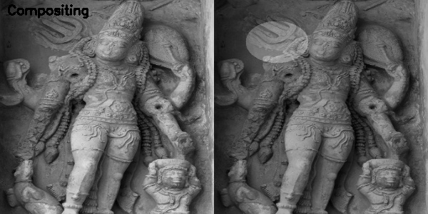
Input Image:
The input image is a grayscale Tamil sculpture image containing detailed textures, smooth intensity variations, and well-defined structural features. The image serves as the base layer for applying visual effects.
Technique Applied:
Digital Compositing involves combining multiple image layers to create a final output image. In this case, a synthetic overlay (circular region) is blended with the original image using weighted addition, modifying specific regions while preserving the underlying structure.
Observed Output:
The output image shows a visible overlay applied to a specific region of the sculpture. The composited region appears brighter and slightly blended with the original image, while the rest of the image remains unchanged. The overall structure and details of the sculpture are preserved, with localized visual modification introduced by the compositing process.
Statistical Analysis:
Pixel-Level Changes:
- Entropy: 7.46 → 7.12
- Slight reduction in intensity variability.
Interpretation:
The small decrease in entropy indicates minor changes in pixel intensity distribution due to blending. Digital compositing modifies only selected regions while preserving the majority of the image information. This technique is useful for visual effects, image editing, and augmentation, allowing controlled alterations without significantly affecting overall image quality.

